Experiment Number: 4

Problem Statement: System Calls

NAME: **Manomay Jamble**  ROLLNO: 49

CLASS: TY(AIDS-A) BATCH: 2

DATE OF PERFORMANCE: 01/09/2022

1. File manipulation (read, write, open)

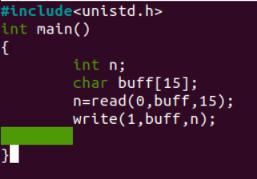

Reading content from f1 to f2 without overwriting

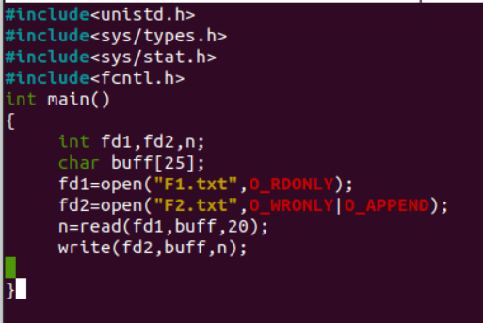

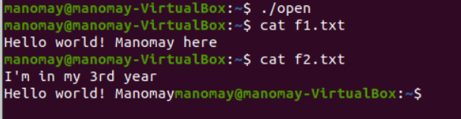

Copy entire content from f1 to f3

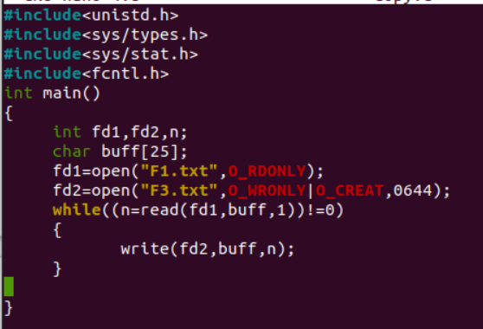

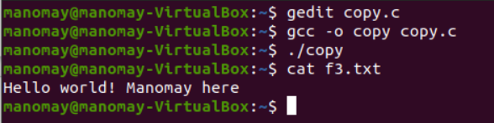

2. Process control system calls

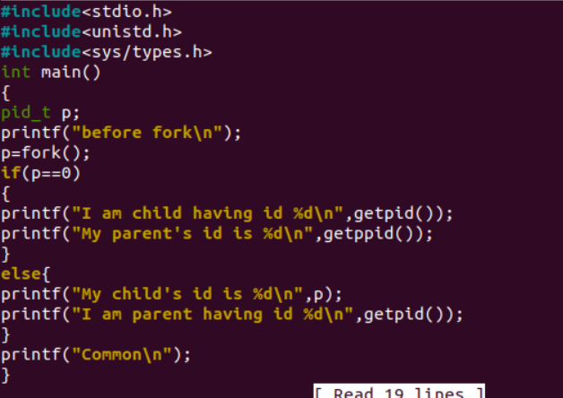

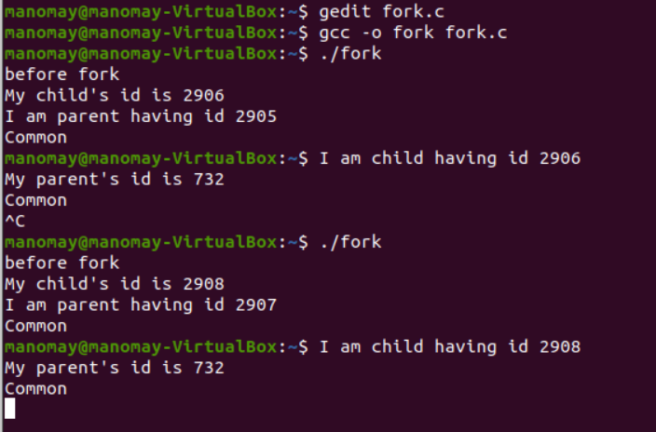

1. Communication System calls (pipe())

